|  |  |
| --- | --- |
| **Name:-** Aryan Dilipbhai Langhanoja | **Roll Number:- 92200133030** |
| **Subject Name and Code:-** Foundation Skills On Sensor Interfacing (01CT1103) | **Date of Experiment:- 13-01-2023** |

|  |  |
| --- | --- |
| Task:- |  |

# Use of While loop

|  |  |
| --- | --- |
| Components: |  |

* Arduino Uno R3
* LED
* Jumper Wires (Male To Male)
* Photoresistor
* Pushbutton
* Laptop Or PC

|  |  |
| --- | --- |
| About the Project:- |  |

* In thisproject, we are going to learn about constraint function. For that we connect photo resistor with analog pin A0 and other terminal we will connect 10Kohm resistor and connect it with GND pin of Arduino. After that we will connect one leg of push button with digital pin 2 and one leg with 5V and one leg one leg to the ground with 10K ohm resistor. And one LED with 10K ohm on pin 9.

|  |  |
| --- | --- |
| Output (you circuit implementation):- |  |

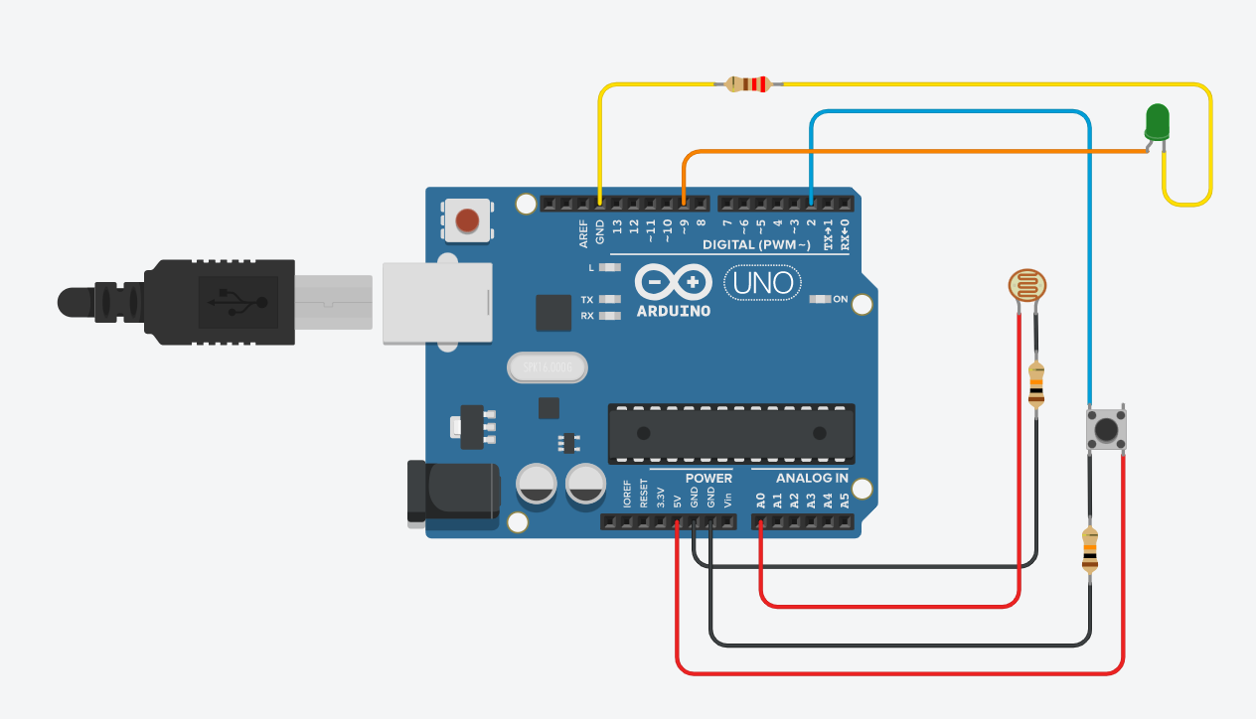

|  |  |  |
| --- | --- | --- |
| Schematic:- |  |  |

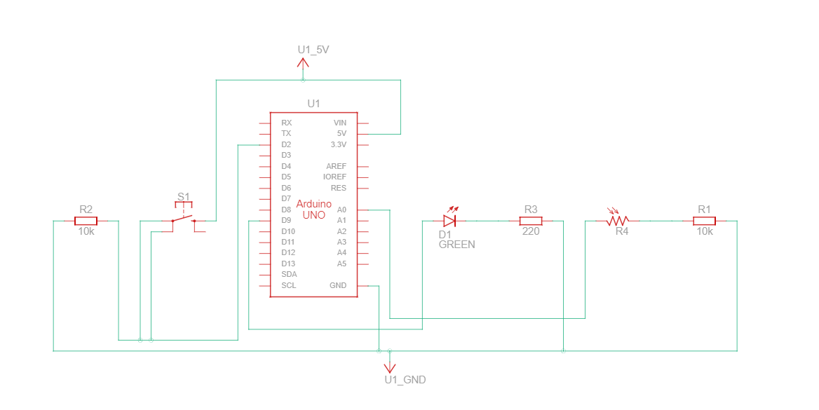

|  |  |
| --- | --- |
| Code:- |  |

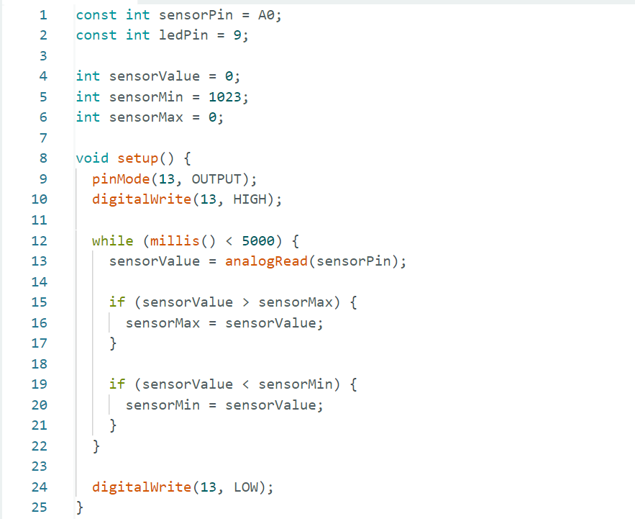

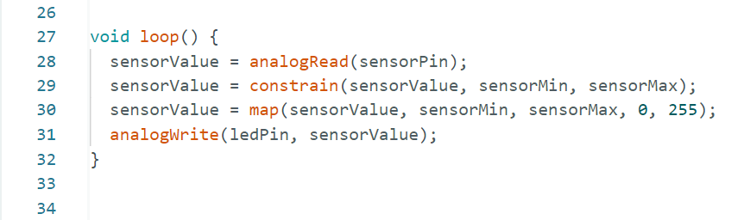

|  |  |
| --- | --- |
| Conclusion:- |  |

* In This Experiment, We learnt about while loop and constraint function.